Bridgepoint Parts Catalog

Section XX: Quick Connects Page 1

100008

1/4” Female Quick Connect

Brass
Prochem Part # 13-806001
Hydramaster Part # 052-051
White Magic Part # B003

100009

1/4” Male Quick Connect

Brass

Prochem Part # 13-806000
Hydramaster Part # 052-050
White Magic Part # B001

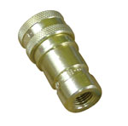
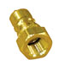

NA0703

1/4” Female Quick Connect

Locking Assembly - Brass

Same size as NA0701 with the additional locking feature to prevent accidental un-couplings

NA010

1/4” Male Quick Connect

Stainless Steel

White Magic Part # B001-1
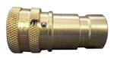
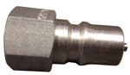

NA012

1/4” Female Quick Connect

Stainless Steel
White Magic Part # B003-1

AS56

Safe Connect – Teal

Plastic Covered - 1/4” Female Quick Connect - Brass

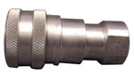
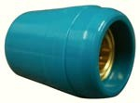

AH102B

1/4” Male Quick Connect

Brass

Hydro-Force Brand

AS56A

Safe Connect – Blue

Plastic Covered - 1/4” Female Quick Connect - Brass

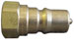
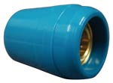

PAF01

3/8” Male Quick Connect

Brass
Prochem Part # 13-806009
Hydramaster Part # 052-052
White Magic Part # B002

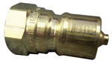

AS56C

Safe Connect – Black

Plastic Covered - 1/4” Female Quick Connect - Brass

BR336

1/4” Female Quick Connect

Flo-Thru – Brass 1/4” FPT

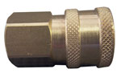

AS56S

Safe Connect – ServPro Green

Plastic Covered - 1/4” Female Quick Connect - Brass

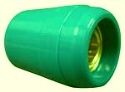

AH101B

1/4” Female Quick Connect

Brass

Hydro-Force Brand

BR337

1/4” Female Quick Connect

Flo-Thru – Brass 1/4” MPT

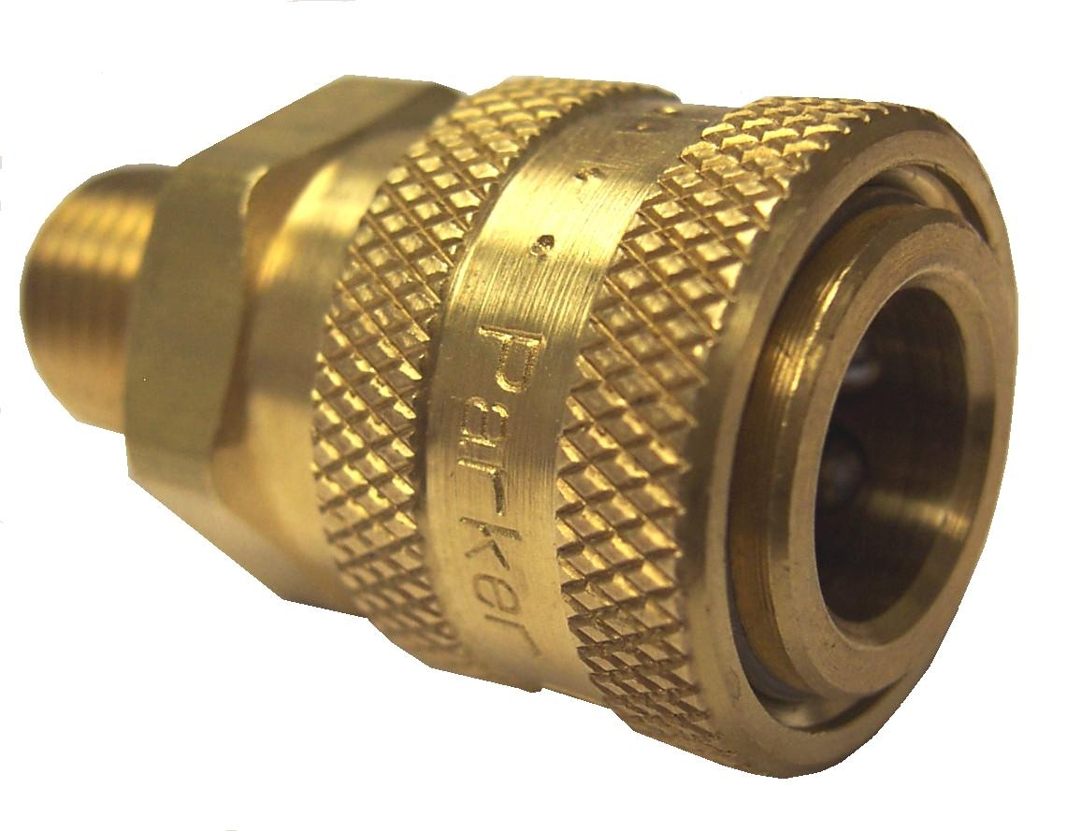
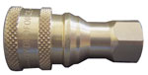

BR338

1/4” Male Quick Connect

Flo-Thru – Brass 1/4” MPT

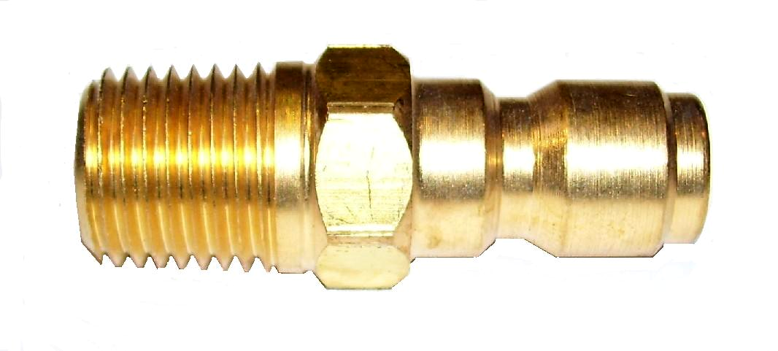

PAF02

3/8” Female Quick Connect

Brass
Prochem Part # 13-806008
Hydramaster Part # 052-053
White Magic Part # B005

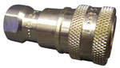

BR335

1/4” Male Quick Connect

Flo-Thru – Brass 1/4” FPT

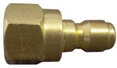

Bridgepoint Parts Catalog

Section XX: Quick Connects Page 2

PAF04

1/8” Female Quick Connect

Brass
Hydramaster Part # 052-049

PAF03

1/8” Male Quick Connect

Brass
Hydramaster Part # 052-048

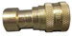
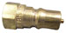

PKL02

1/8” Female Quick Connect

Flo-Thru – Stainless Steel

1/8” FPT

PKL01

1/8” Male Quick Connect

Flo-Thru – Stainless Steel

1/8” FPT
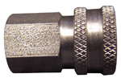
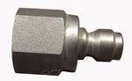

100005

1/8” Male Quick Connect

Flo-Thru – Brass

1/8” FPT

NA034

1/8” Female Quick Connect

Flo-Thru – Brass

1/8” FPT

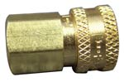
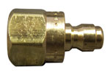

PKLF01

1/8” Male Quick Connect

Flo-Thru – Brass

1/8” MPT

NM3006

Quick Connect – Female

Solvent Inlet - System III

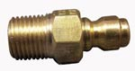
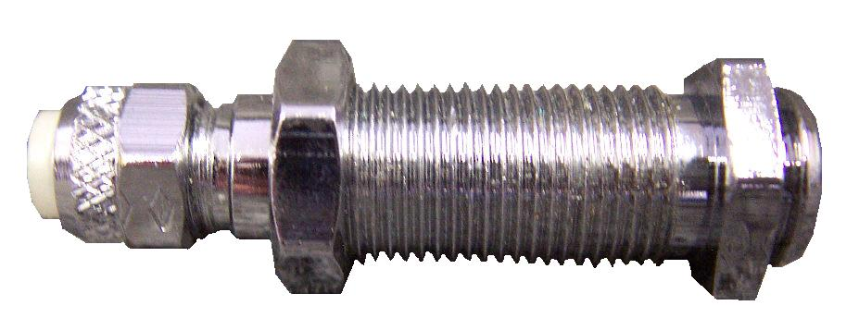

PP13-806003

Quick Connect – Male

Solvent Hose - System III

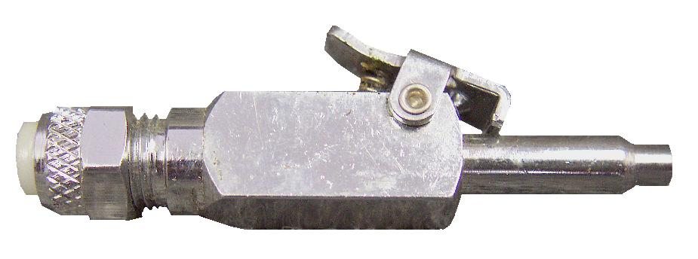

PAF14

3/8” Male Air Quick Connect

1/4” FPT - Steel

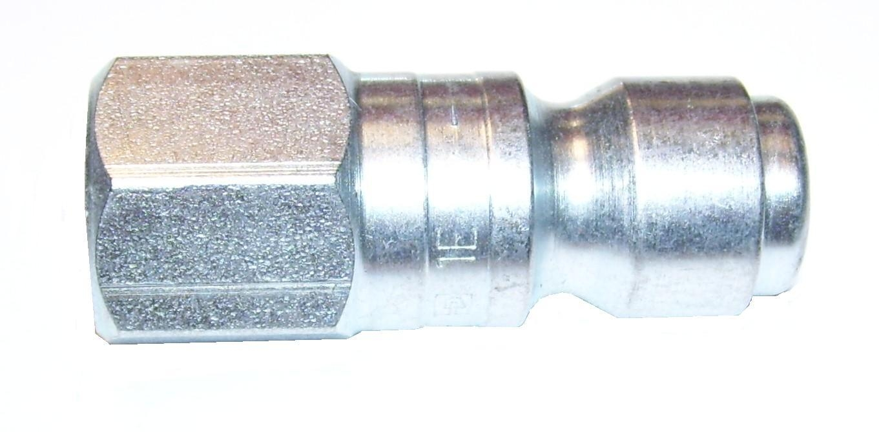

NM3017

Quick Connect – Female

Solution Outlet - System III
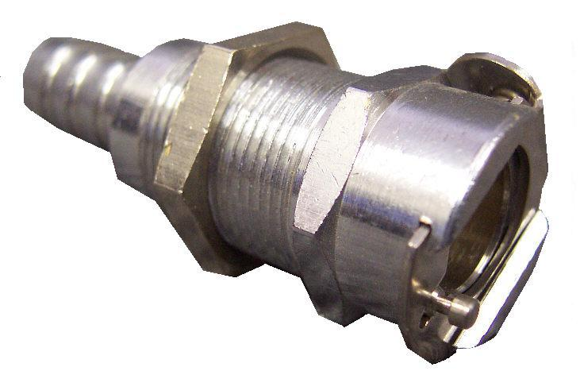

PAF16

3/8” Female Air Quick Connect

1/4” FPT - Steel

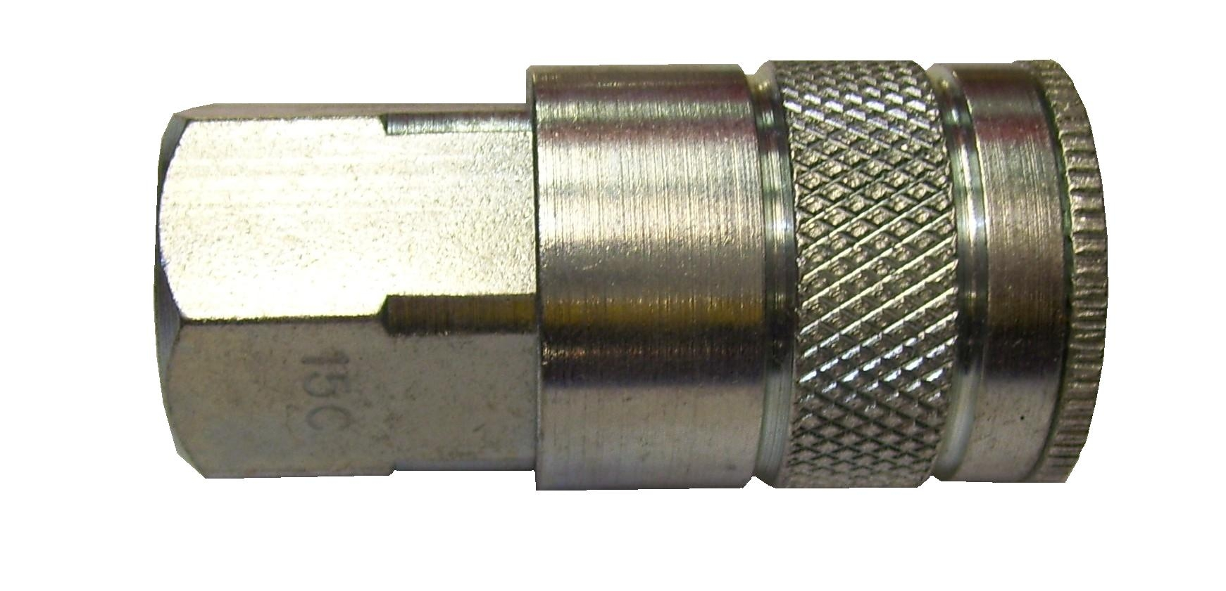

NM3055

Quick Connect – Male

Solution Hose - System III
1/4” MPT

AS54

Sleeve Set 1/4” M & F

Quick Connects

Black – Vinyl

AS54A – Male Sleeve AS54B – Female Sleeve

PWM-B003-M

1/4” Female Quick Connect

Brass – Modified

Nipple removed and hole enlarged to fit over filter screen.

PWM-B001-M

1/4” Male Quick Connect

Brass – Modified

Nipple removed and tip modified to accept filter screen.
Filter: PS12687-100

PAFBST-4M

1/2” Female Quick Connect

Flo-Thru – Brass 1/2” MPT

PAFBST-N4M

1/2” Male Quick Connect

Flo-Thru – Brass 1/2” MPT

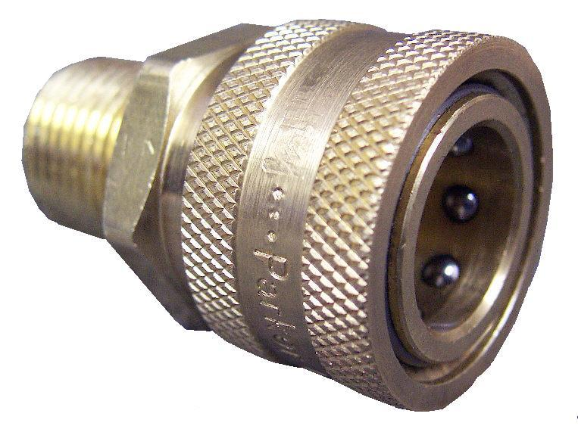
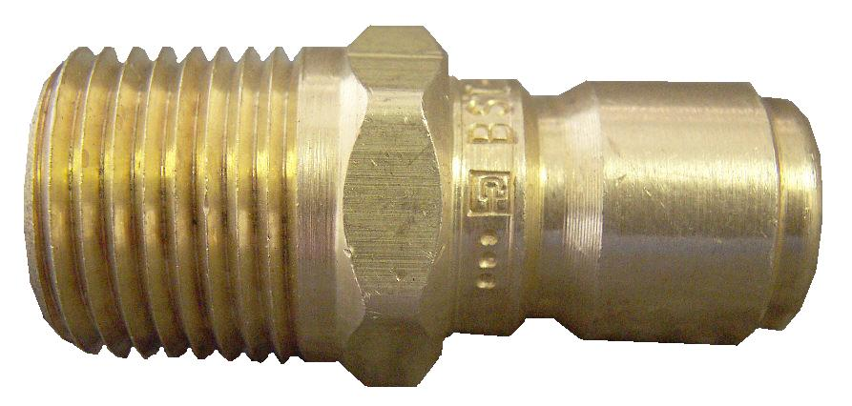

Bridgepoint Parts Catalog

Section XX: Quick Connects Page 3

NM4200

1/2” Female Quick Connect

Brass

NM4202

3/4” Female Quick Connect

Brass

NM4201

1/2” Male Quick Connect

Brass

AH104

TES Inlet Solution Tee – Brass

(1) 3/4” Female QC

(2) 1/2” Male QC

NM4203

3/4” Male Quick Connect

Brass

PPH001

Coupler Body Dehumidifier

Pump-out 0.38” Barb - Plastic
Phoenix: 4023079

PPH002

Coupler Insert Dehumidifier

Pump-out 0.38” Barb - Plastic
Phoenix: 4023080
Dri-Eaz: 08-00303

AH106

TES Outlet Solution Tee – Brass

3/4” Male QC

1/2” Female QC

AH115

TES Outlet Solution Tee - Brass

(1) 3/4” Male QC

(3) 1/2” Female QC

PPH003

Coupler Body Dehumidifier

Pump-out 0.25” Barb - Plastic
Phoenix: 4024910
Dri-Eaz: 08-00302

AH119

TES Inlet Solution Tee – Brass

3/4” Female QC

(3) 1/2” Male QC

PHY052-697

Female Quick Connect – SS

Chem Dry Chemical Inlet
90˚ Elbow with Barb

PHY052-698

Female Quick Connect – SS

Chem Dry Chemical Outlet
90˚ Elbow with Barb

AH105

TES Outlet Solution Tee - Brass

(1) 3/4” Male QC

(4) 1/2” Female QC

AH103

TES Inlet Solution Tee – Brass

3/4” Female QC

(4) 1/2” Male QC

PMF095

Quick Connect 1/8” Female

Flo-thru - 1/8” FPT - Brass
For AW20S Tool

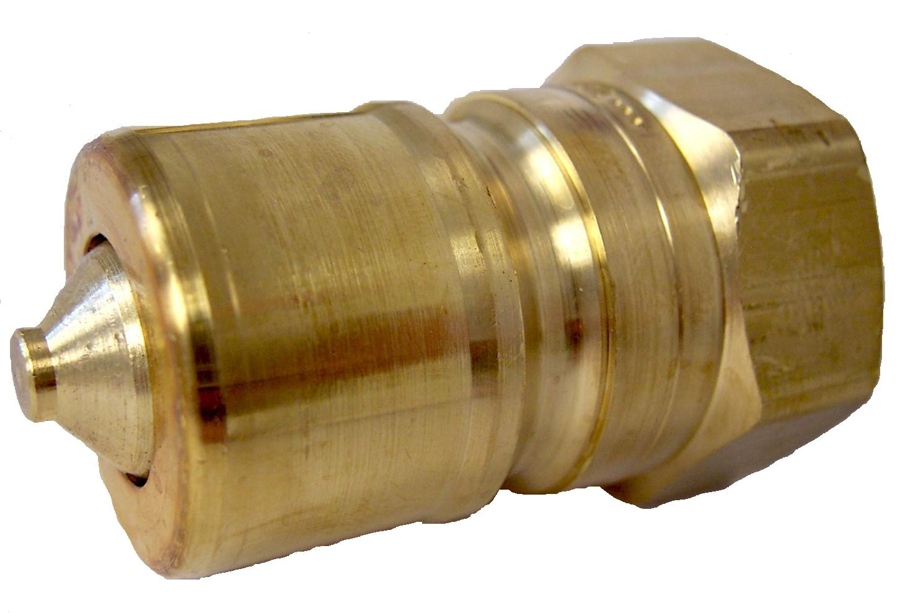
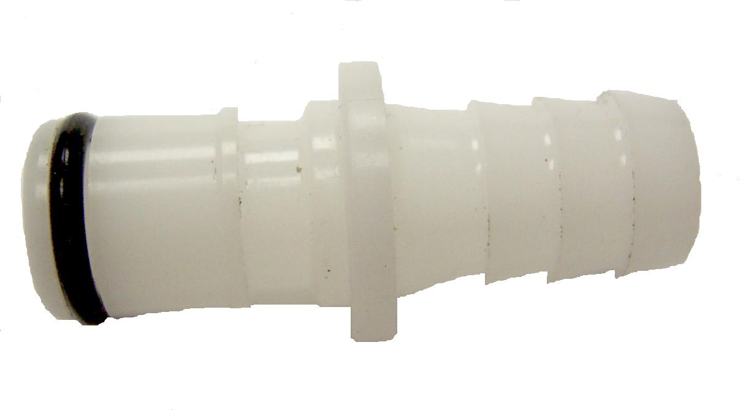
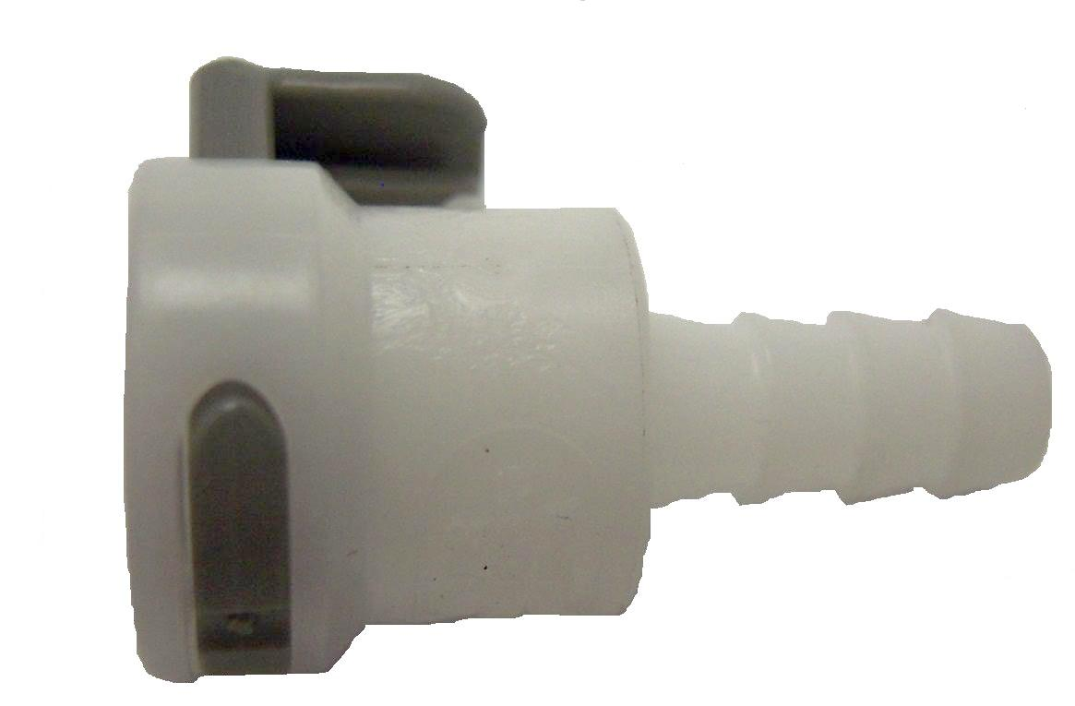
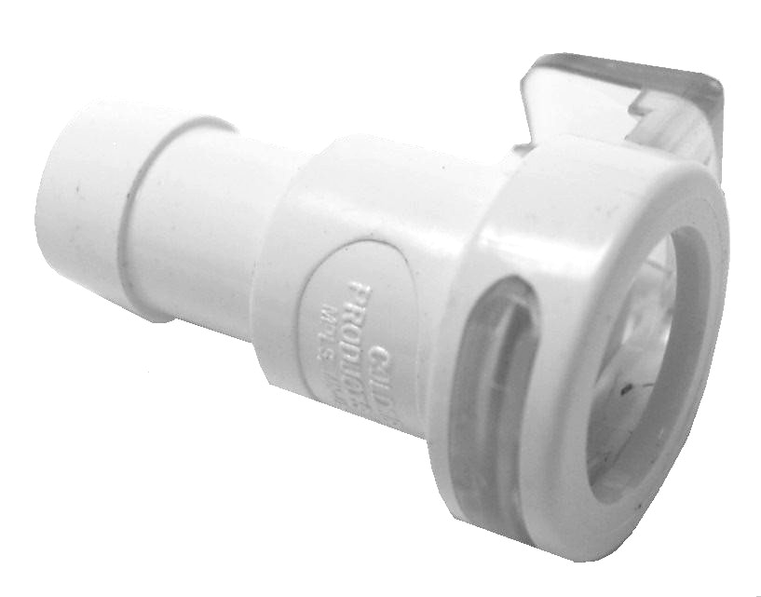
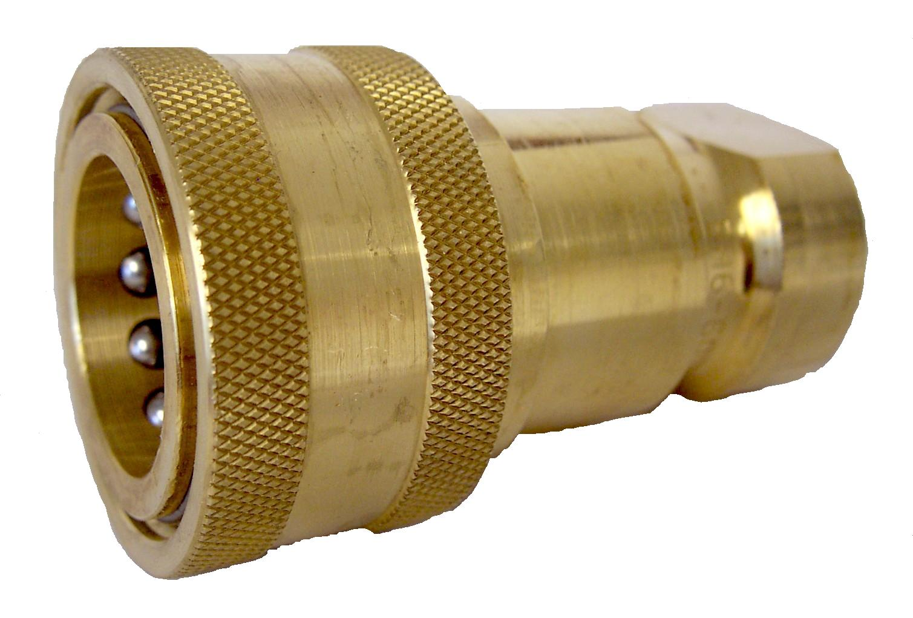
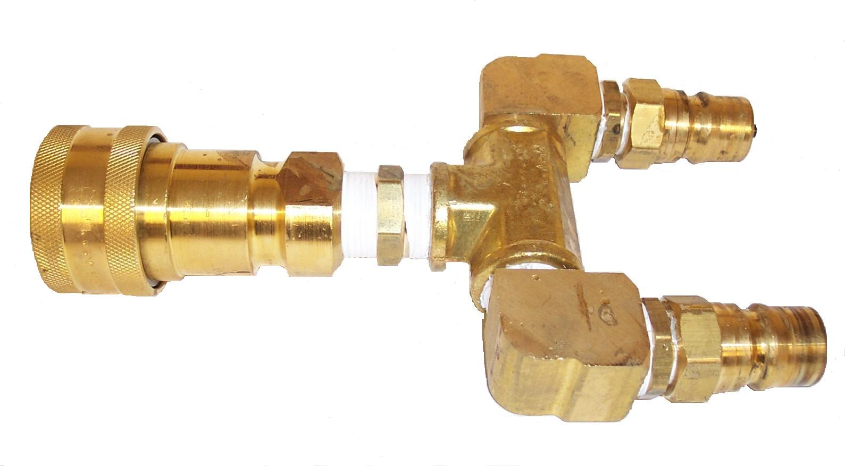
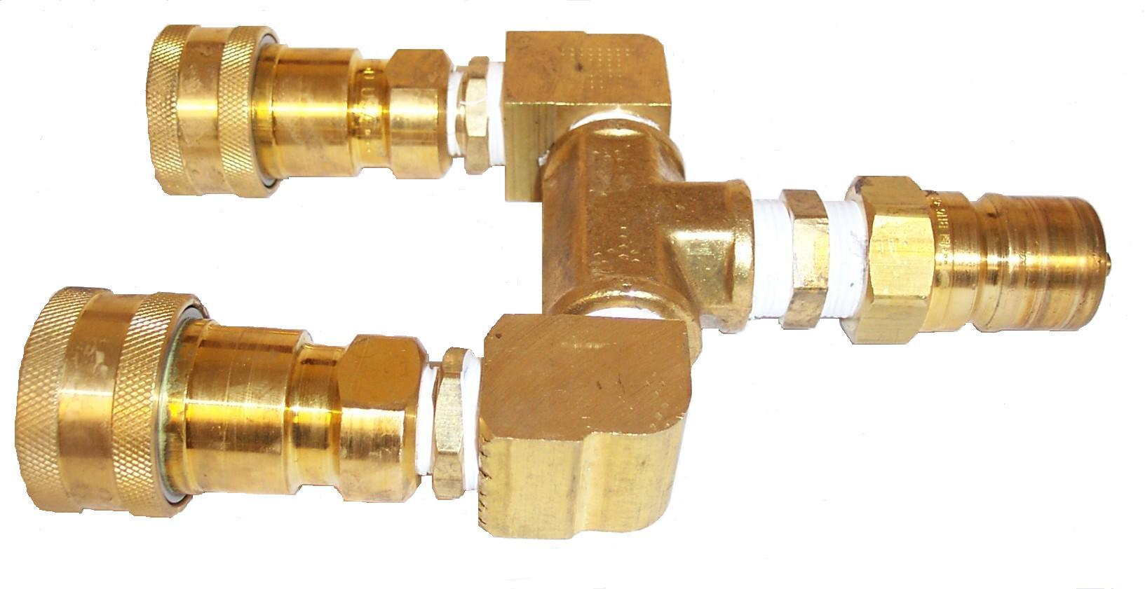
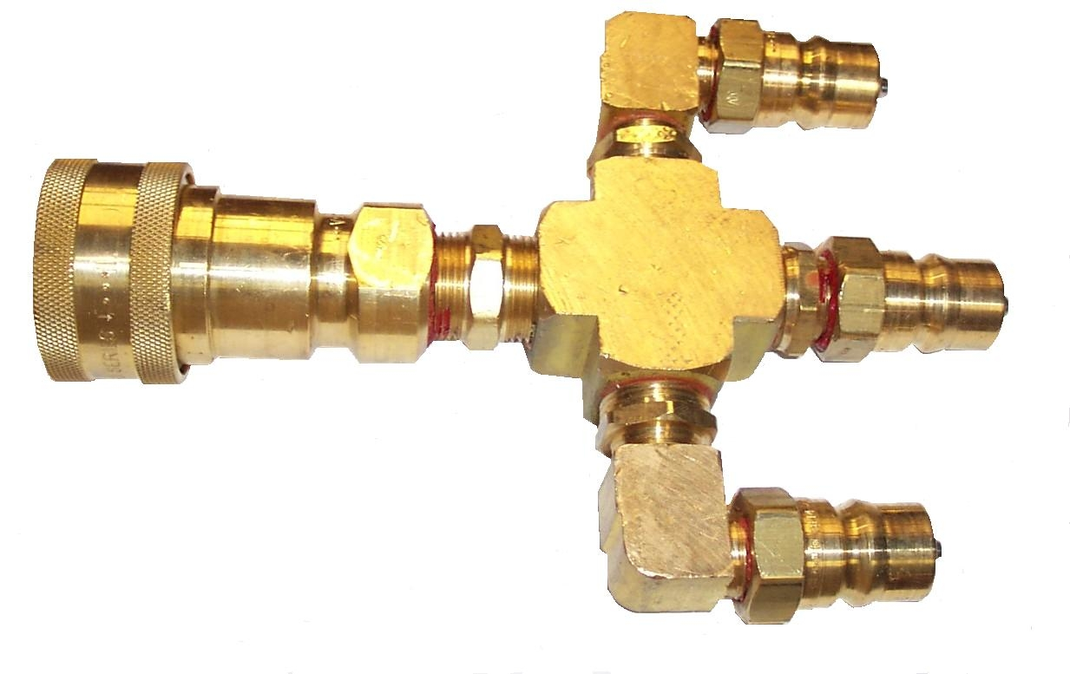
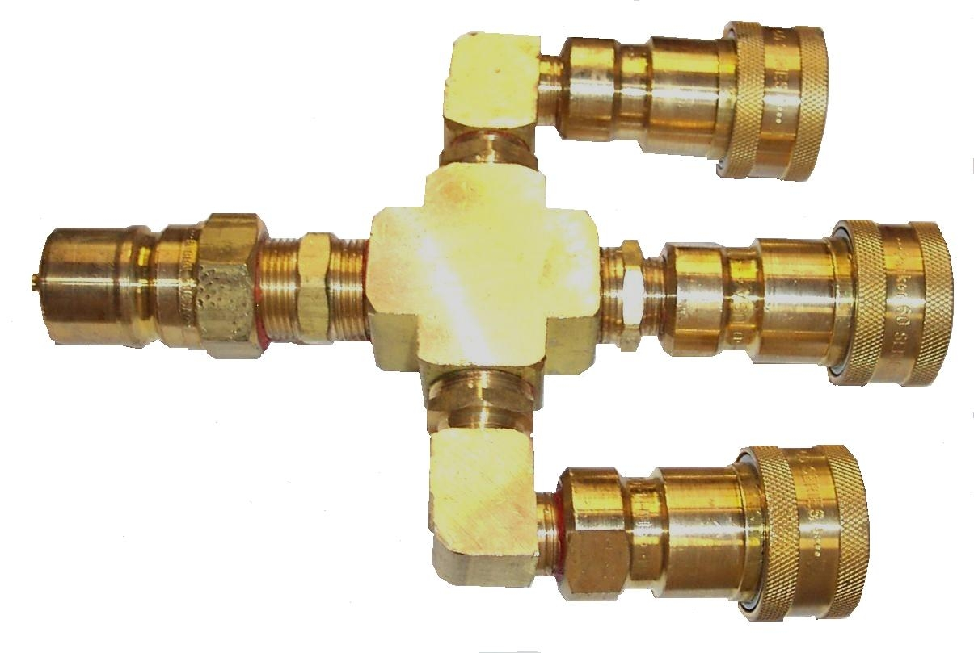
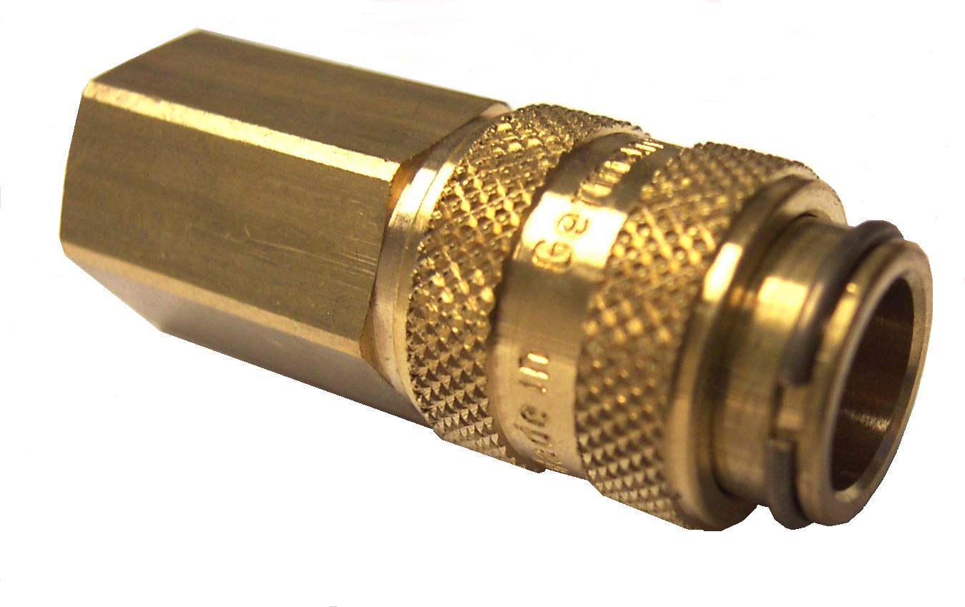

PMF090

Quick Connect 1/8” Male

Flo-thru - 1/8” FPT – Brass
For AW20S Tool

